***Chemistry***

**14: Acid-Base Equilibria**

**14.6: Buffers**

87. Explain why the pH does not change significantly when a small amount of an acid or a base is added to a solution that contains equal amounts of the acid H3PO4 and a salt of its conjugate base NaH2PO4.

Solution

Excess  is removed primarily by the reaction:



Excess base is removed by the reaction:



89. What is  in a solution of 0.25 *M* CH3CO2H and 0.030 *M* NaCH3CO2?



Solution

The equilibrium expression is:



The initial and equilibrium concentrations for this system can be written as follows:

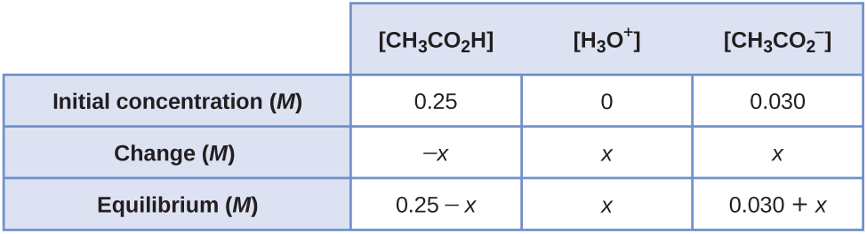

Substituting the equilibrium concentrations into the equilibrium expression, and making the assumptions that (0.25 – *x*) ≈ 0.25 and (0.030 – *x*) ≈ 0.030, gives:



Solving for *x* gives 1.50  10–4*M*. Because this value is less than 5% of both 0.25 and 0.030, our assumptions are correct. Therefore,  = 1.5  10–4 *M*.

This problem can also be solved using the Henderson-Hasselbalch equation: ; p*K*a = –log(*K*a) = –log(1.8  10–5) = 4.74; [HA] ≈ [HA]0 = [CH3CO2H]0 = 0.25*M*; [A–] ≈ [NaCH3CO2] = 0.030 *M*. Using these data: ; = 10–pH *M* = 10–3.82 *M* = 1.5  10–4 *M*

91. What is [OH–] in a solution of 0.125 *M* CH3NH2 and 0.130 *M* CH3NH3Cl?



Solution

The equilibrium expression is:



The initial and equilibrium concentrations for this system can be written as follows:

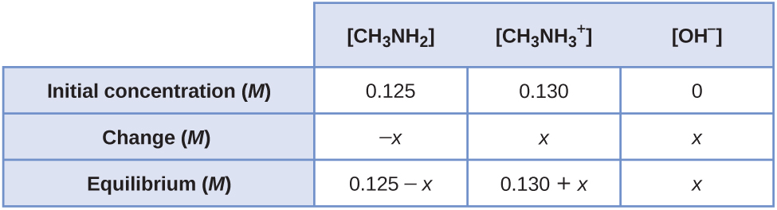

Substituting the equilibrium concentrations into the equilibrium expression, and making the assumptions that (0.125 – *x*) ≈ 0.125 and (0.130 – *x*) ≈ 0.130, gives:



Solving for *x* gives 4.23  10–4 *M*. Because this value is less than 5% of both 0.125 and 0.130, our assumptions are correct. Therefore, [OH–] = 4.2  10–4 *M*.

93. What concentration of NH4NO3 is required to make [OH–] = 1.0  10–5 in a 0.200-*M* solution of NH3?

Solution

The reaction and equilibrium constant are:



The equilibrium expression is:



Let *x* = the concentration of NH4NO3 required. The initial and equilibrium concentrations for this system can be written as follows:

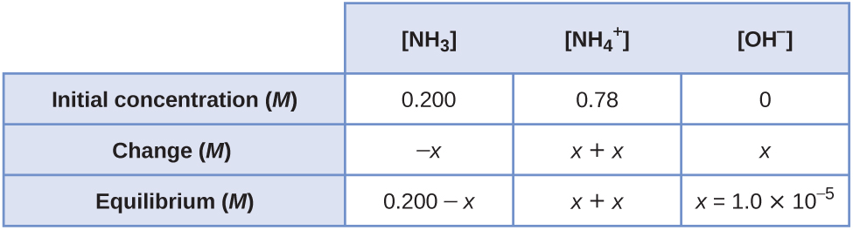

Substituting the equilibrium concentrations into the equilibrium expression, and making the assumption that (*x* + *x*) ≈ *x*, gives:



Solving for *x* gives 0.360 *M*. Because *x* is less than 5% of this value, our assumption is correct. Therefore,  = [NH4NO3] = 0.36 *M*.

95. What is the effect on the concentration of acetic acid, hydronium ion, and acetate ion when the following are added to an acidic buffer solution of equal concentrations of acetic acid and sodium acetate:

(a) HCl

(b) KCH3CO2

(c) NaCl

(d) KOH

(e) CH3CO2H

Solution

The reaction and equilibrium constant are:



(a) The added HCl will increase the concentration of  slightly, which will react with and produce CH3CO2H in the process. Thus,  decreases and [CH3CO2H] increases.

(b) The added KCH3CO2 will increase the concentration of which will react with  and produce CH3CO2 H in the process. Thus,  decreases slightly and [CH3CO2H] increases.

(c) The added NaCl will have no effect on the concentration of the ions.

(d) The added KOH will produce OH– ions, which will react with the , thus reducing . Some additional CH3CO2H will dissociate, producing ions in the process. Thus, [CH3CO2H] decreases slightly and increases.

(e) The added CH3CO2H will increase its concentration, causing more of it to dissociate and producing more and  in the process. Thus, increases slightly and increases.

97. What will be the pH of a buffer solution prepared from 0.20 mol NH3, 0.40 mol NH4NO3, and just enough water to give 1.00 L of solution?

Solution

The reaction and equilibrium constant are:



The equilibrium expression is:



The initial concentrations of NH3 and  are 0.20 *M* and 0.40 *M*, respectively. The equilibrium concentrations for this system can be written as follows:

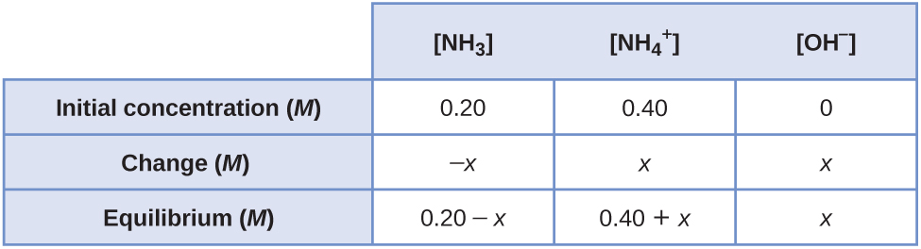

Substituting the equilibrium concentrations into the equilibrium expression, and making the assumptions that (0.20 – *x*) ≈ 0.20 and (0.40 + *x*) ≈ 0.40, gives:



Solving for *x* gives 9.00  10–6 *M*. Because this value is less than 5% of both 0.20 and 0.40, our assumptions are correct. Therefore, [OH–] = 9.00  10–6 *M*. Thus:

pOH = –log(9.00  10–6) = 5.046

pH = 14.000 – pOH = 14.000 – 5.046 = 8.954 = 8.95

99. How much solid NaCH3CO2•3H2O must be added to 0.300 L of a 0.50-*M* acetic acid solution to give a buffer with a pH of 5.00? (Hint: Assume a negligible change in volume as the solid is added.)

Solution

The reaction and equilibrium constant are:



The equilibrium expression is:



Let *x* be the concentration of . The hydronium ion concentration at equilibrium is:

 = 10–pH = 10–5.00 = 1.00  10–5 *M*

The initial and equilibrium concentrations for this system can be written as follows:

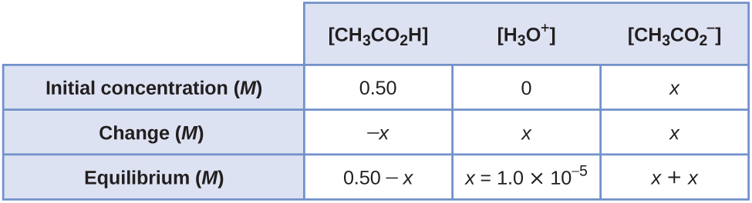

Substituting the equilibrium concentrations into the equilibrium expression, and making the assumption that (*x* + *x*) ≈ *x*, gives:



Solving for *x* gives 0.900 *M*. Because *x* is less than 5% of this value, our assumption is correct. Therefore,  = 0.900 *M*. Using the molar mass of NaC2H3O2·3H2O (136.080 /mol) and the volume gives the mass required:



101. A buffer solution is prepared from equal volumes of 0.200 *M* acetic acid and 0.600 *M* sodium acetate. Use 1.80  10–5 as *K*a for acetic acid.

(a) What is the pH of the solution?

(b) Is the solution acidic or basic?

(c) What is the pH of a solution that results when 3.00 mL of 0.034 *M* HCl is added to 0.200 L of the original buffer?

Solution

(a) The reaction and equilibrium constant are:



The equilibrium expression is:



The molar mass of NH4Cl is 53.4912 g/mol. The moles of NH4Cl are: 

Assume 0.500 L of each solution is present The total volume is thus 1.000 L. The initial concentrations of the ions is obtained using *M*1*V*1 = *M*2*V*2, or:



The initial and equilibrium concentrations of this system can be written as follows:

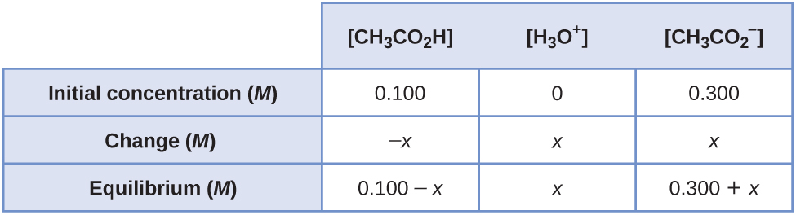

Substituting the equilibrium concentrations into the equilibrium expression, and making the assumptions that (0.100 – *x*) ≈ 0.100 and (0.300 – *x*) ≈ 0.300, gives:



Solving for *x* gives 6.000  10–6 *M*. Because this value is less than 5% of both 0.100 and 0.300, our assumptions are correct. Therefore  = 6.000  10–6 *M*:

pH = –log(6.000  10–6) = 5.2218 = 5.222;

(b) The solution is acidic.

(c) Assume that the added H+ reacts completely with an equal amount of , forming an equal amount of CH3CO2H in the process. The moles of H+ added equal 0.034 *M*  0.00300 L = 1.02  10–4 mol. For the acetic acid, the initial moles present equal 0.2000 *M*  0.500 L = 0.1000 mol, and for acetate ion, 0.600 *M*  0.500 L = 0.3000 mol. Thus:

mol CH3CO2H = 0.1000 + 1.02  10–4 = 0.1001 mol



Final volume = 1.000 L + 3.00  10–3 L = 1.0030 L

The initial concentrations are therefore:





The initial and equilibrium concentrations for this system can be written as follows:

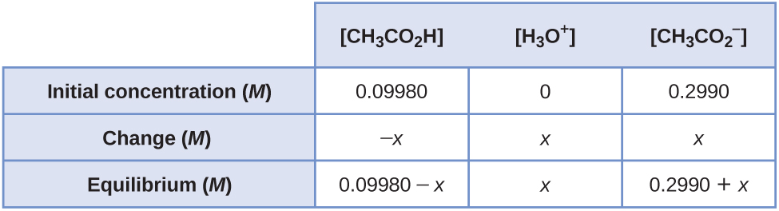

Substituting the equilibrium concentrations into the equilibrium expression, and making the assumptions that (0.09980 – *x*) ≈ 0.09980 and (0.2990 – *x*) ≈ 0.2990, gives:



Solving for *x* gives 6.008  10–6 *M*. Because this value is less than 5% of both 0.09980 and 0.2990, our assumptions are correct. Therefore,  = 6.008  10–6*M*.

pH = –log(6.008  10–6) = 5.2213 = 5.221

103. Which acid in Table 14.2 is most appropriate for preparation of a buffer solution with a pH of 3.1? Explain your choice.

Solution

To prepare the best buffer for a weak acid HA and its salt, the ratio  should be as close to 1 as possible for effective buffer action. The  concentration in a buffer of pH 3.1 is  = 10–3.1 = 7.94  10–4 *M*

We can now solve for *K*a of the best acid as follows:



In Table 14.2, the acid with the closest *K*a to 7.94  10–4 is HNO2, with a *K*a of 4.6  10–4.

105. Which base in Table 14.3 is most appropriate for preparation of a buffer solution with a pH of 10.65? Explain your choice.

Solution

For buffers with pHs > 7, you should use a weak base and its salt. The most effective buffer will have a ratio that is as close to 1 as possible. The pOH of the buffer is 14.00 – 10.65 = 3.35. Therefore, [OH–] is [OH–] = 10–pOH = 10–3.35 = 4.467  10–4 *M*.

We can now solve for *K*b of the best base as follows:



*K*b = [OH–] = 4.47  10–4

In Table 14.3, the base with the closest *K*b to 4.47  10–4 is CH3NH2, with a *K*b = 4.4  10–4.

107. Saccharin, C7H4NSO3H, is a weak acid (*K*a = 2.1  10–2). If 0.250 L of diet cola with a buffered pH of 5.48 was prepared from 2.00  10–3 g of sodium saccharide, Na(C7H4NSO3), what are the final concentrations of saccharine and sodium saccharide in the solution?

Solution

The molar mass of sodium saccharide is 205.169 g/mol. The number of moles used to prepare the solution is:



This molar amount represents the total amount of this substance present in the solution, regardless of whether it’s present in its basic form (saccharide, symbolized A- below) or its acidic form (saccharin, symbolized HA below). The total concentration of these conjugate partners is thus



The concentration of each partner is conveniently computed using the Henderson-Hasselbalch equation:



where the pKa for saccharin is computed from the provided value of its Ka:



Rearranging the above equation for total concentration and substituting into the Henderson-Hasselbalch equation yields



Substituting the provided pH and pKa values and rearranging permits calculation of [HA]:



The concentration of the basic form is then



This result is consistent with expectations: since the solution pH is well above the pKa of the substance (5.48 > 1.68), the basic form of the substance, saccharide, will be the dominant partner (its concentration is about 10,000-times greater than that of the acid).

This resource file is copyright 2015, Rice University. All Rights Reserved.